

**ALMAAREFA University**

**College of Applied Scineces**

**Department of Computer Science and Information Systems**

**Project Title**

**English:**

**Rifad:**

**A Smart VR-Based Medical Training Platform for Health Procedures**

**Arabic:**

**رِفاد**

منصة تدريب صحي ذكية باستخدام الواقع الافتراضي للإجراءات الطبية

**Team members:**

|  |  |
| --- | --- |
| ID | Name |
| 212220737 | Noor Khalid Abouissa |

**Supervisor:**

**Dr.Nasriah**

A report submitted in part fulfilment of the degree of BSc in [Computer Science /Information Systems/ Health Information Systems]

**2024 – 2025**

**Contents**

Abstract: 1

Chapter One: Introduction 3

1.1: Introduction: 3

1.2 Project Description: 3

1.3 Project Purpose: 3

1.4 Problem Statement: 3

1.5 The System Context View: 3

1.6 System Requirements: 3

1.8 Challenges: 3

1.9 Projection: 3

1.10 Ethical Considerations 3

Chapter Two: Literature Review 4

2.1: Background 4

2.2: Literature Review 4

2.3 The Existing Solutions 4

Chapter Three: System Architecture and Design 5

3.1 Introduction: 5

3.2 Methodology: 5

3.3 System Architecture 5

3.4 Structural model 5

3.5 Detailed System Architecture 5

3.6 User Interface 5

3.7 Quality Assurance 5

3.8 Acceptance Criteria 5

3.9 Future Consideration 5

Chapter Four: Experimental Setup and Configuration 6

4.1 Hardware and Software Setup: 6

4.2 Installation and Configuration: 6

4.3 Tools and Technologies Used: 6

4.4 System Training (for AI systems) 6

4.5 Testing and Validation: 6

4.6 Risk Analysis and Mitigation: 6

Chapter Five: Results and Discussion 7

5.1 Results: 7

5.2 Discussion: 7

5.3 Limitations: 7

Chapter Six: Conclusion 8

6.1 Summary of Work: 8

6.2 Lessons Learned: 8

6.3 Future Work: 8

References 9

Appendices 10

A1. Project Timeline 10

A2. Source Code Documentation 10

A3. User Manuals 10

A4. Additional Diagrams 10

# 

# Abstract:

**Rifad is an innovative smart training platform that combines 3D medical simulation with a web-based interface to teach clinical procedures. Originally developed as a VR simulation for blood draw training, the platform now includes a full website where users can register, log in, access simulations, and receive personalized performance reports. Designed for health science students, home caregivers, and the general public, Rifad allows users to practice essential procedures in a safe, repeatable, and feedback-driven environment—accessible on desktop, without requiring VR hardware. Future versions will add more scenarios and cloud-based progress tracking.**

# Chapter One: Introduction

## 1.1: Introduction:

**With the rise of digital transformation in healthcare education, virtual reality (VR) has become a powerful tool to simulate clinical procedures and enhance medical skills without real-world risks. Rifad is a smart VR-based training platform designed to simulate essential healthcare procedures such as blood draw, enabling students and caregivers to learn in an immersive, controlled environment. The recent addition of a complementary website allows users to register, log in, access the simulation, and later download a performance report, improving usability and extending accessibility.**

## 1.2 Project Description:

**Rifad combines a WebGL-based Unity simulation with an integrated website built using HTML, CSS, PHP, and MySQL. Users can register as medical students, caregivers, or public learners and access VR simulations directly through the dashboard. The simulation offers a step-by-step blood draw process with an AI assistant for guidance and performance tracking. The system now supports storing user profiles and tracking usage via a backend database.**

## 1.3 Project Purpose:

## **To create a hybrid VR and web-based medical training system that makes clinical education more accessible, especially for students and home caregivers. The goal is to reduce the dependency on physical labs and provide real-time feedback with continuous access to virtual learning, anytime, anywhere.**

## 1.4 Problem Statement:

## **Traditional medical training relies heavily on limited-access resources such as physical manikins and direct supervision, which may not be feasible for all learners. Additionally, caregivers in households with chronically ill patients often lack formal training. There is a clear need for a scalable, interactive solution that offers practical, guided, and error-tolerant learning experiences.**

## 1.5 The System Context View:

**Rifad will interact with multiple user categories and components, including:**

* **Healthcare students and faculty in training institutions**
* **Family caregivers supporting patients at home**
* **VR-compatible devices and desktop systems**
* **A responsive website where users can register, log in, and access the VR simulation via desktop**
* **A cloud-based backend for data collection and user progress tracking**

## 1.6 System Requirements:

* **VR Environment Engine: Built using Unity for immersive interaction**
* **Interactive Modules: Step-by-step blood draw simulation with logical validation**
* **Feedback System: Real-time alerts and encouragement messages**
* **Performance Tracker: Evaluation of user actions with scoring**
* **AI Assistant: Guided responses to user questions (predefined knowledge base)**
* **Desktop Compatibility: Simulated version for users without VR hardware**

## 1.8 Challenges:

* **Ensuring realism while simplifying the experience for accessibility**
* **Providing accurate medical guidance without physical sensation feedback**
* **Balancing educational rigor with user-friendly design**
* **Technical integration of AI logic with VR interactions**

## 1.9 Projection:

## **Rifad is projected to reduce training anxiety, enhance skill retention, and extend medical education to wider audiences. It will be applicable in universities, health institutes, and even homes, enabling caregivers to perform procedures more confidently and correctly.**

## 1.10 Ethical Considerations:

**The system must ensure users are aware that virtual training does not replace clinical supervision. Educational content will follow licensed health standards. Additionally, user data and performance records will be handled confidentially and in compliance with ethical research and data privacy standards.**

# 

# Chapter Two: Literature Review

## 2.1: Background:

## **Simulation-based training has become an essential tool in health education, helping students and caregivers learn complex procedures in a safe, controlled environment. Virtual Reality (VR) enhances this by immersing learners in realistic scenarios without the risks associated with real-life patient interaction. The use of VR in clinical training enables students and non-specialist caregivers to practice procedures like blood draw, wound care, and emergency responses repeatedly and independently. As healthcare systems move toward digitization and self-learning tools, VR-based platforms are becoming increasingly valuable.**

## **Relevant Terminology:**

## **VR Simulation: A computer-generated environment that allows users to interact with 3D elements as if they were in a real clinical setting.**

## **Immersive Learning: A training approach where learners are deeply engaged in a virtual experience that mimics real-life situations.**

## **Caregiver Training: Education aimed at non-professionals who provide care to chronically ill family members at home.**

## **First Aid Procedures: Basic medical interventions used to treat urgent health conditions until professional help arrives.**

## **Interactive Feedback: Real-time system responses that guide learners during simulation to correct mistakes and reinforce proper steps.**

## 2.2: Literature Review:

* **Virtual Reality (VR) has emerged as a powerful educational tool in medical and health science training, offering immersive, safe, and repeatable environments for skill development. According to Kyaw et al. (2019), VR-based learning significantly improves learners' clinical knowledge, procedural performance, and confidence compared to traditional teaching methods. Their systematic review emphasized VR's role in enhancing both cognitive and psychomotor outcomes across various medical fields.**
* **Freina and Ott (2015) conducted a foundational review that identified VR as a promising medium for experiential learning. They noted that VR environments engage learners more deeply and improve long-term retention of clinical knowledge, particularly in complex and high-risk scenarios.**
* **Foronda et al. (2020) focused specifically on nursing education and found that immersive virtual simulation not only improved students’ skills but also helped them manage stress and anxiety in critical situations. This aligns with the objective of the Rifad project, which aims to provide stress-free, self-paced clinical training for students and caregivers alike.**
* **Furthermore, a study by Levine et al. (2018) highlighted the lack of structured training tools for informal caregivers who manage chronically ill family members. Their findings support the need for accessible training platforms that extend beyond academic institutions—something that Rifad directly addresses.**

**These studies collectively support the integration of VR into medical education and suggest a research gap in the availability of VR tools designed for both professional learners and non-specialist caregivers, especially in Arabic-speaking regions.**

## 2.3 The Existing Solutions:

**Several platforms and tools offer VR-based medical training, including:**

**1. SimX:**

**A professional VR simulation used by hospitals and universities. It enables team-based scenarios such as trauma care and emergency response.**

**Strength: High realism and flexibility.**

**Limitation: Requires advanced VR hardware and high licensing costs.**

**2. Oxford Medical Simulation (OMS):**

**Used for clinical decision-making simulations, especially in emergency settings.**

**Strength: Includes a wide range of case studies.**

**Limitation: Focuses on advanced learners; not accessible to public users or caregivers.**

**3. Body Interact:**

**Offers virtual patients for diagnostic and treatment decision-making.**

**Strength: Interactive and available for institutions.**

**Limitation: Not focused on procedural skills like blood draw or basic care.**

**Suggested insertion :**

**In contrast to many existing solutions that require advanced hardware or institutional access, Rifad introduces a more inclusive model by integrating its simulation into a web-based platform, making it accessible from any browser with WebGL support. This broadens its usability for home caregivers and students without high-end VR setups.**

# Chapter Three: System Architecture and Design

## 3.1 Introduction:

**This chapter outlines the overall design of Rifad, a VR-based training system aimed at simulating clinical procedures. The system guides users through step-by-step interactions, provides real-time feedback, tracks performance, and includes a virtual assistant for educational support. The design ensures a user-friendly and educational experience, optimized for desktop and VR headsets.**

## 3.2 Methodology:

**Main Phases of Development:**

**1. Planning and Scenario Design:**

* **Identified the key training scenario: Blood Draw Procedure**
* **Defined the users: Medical students, caregivers, general public**
* **Mapped out the step-by-step process the simulation should follow**

**2. Environment and Asset Setup:**

* **Built the 3D scene in Unity 2022.3 using the 3D Core template**
* **Imported or created assets: hand model, table, medical tools (gloves, cannula, tape, etc.)**
* **Positioned the camera and user view to simulate clinical perspective**

**3. Interaction Design and Scripting:**

* **Created interactive scripts in C# for:**
* **Tool selection and activation**
* **Feedback system (e.g., "Correct Step", "Missed Step")**
* **Smart assistant logic (cannula recommendation based on vein type)**
* **Integrated UI elements such as buttons, tooltips, and end report panel**

**4. Testing and Feedback Integration:**

* **Each step was tested individually and as part of the full workflow**
* **Errors and success logs were tracked to generate a final performance report**
* **Adjustments were made based on user feedback and realism**
* **Tools and Technologies Used:**
* **Unity Engine 2022.3 (LTS) - for building the 3D environment and interactions**
* **C# Programming - for logic, feedback, and user interaction**
* **Blender / Asset Store - for 3D models**
* **Draw.io / Canva - for architectural diagrams**

**5.Web Platform Integration:**

* **Developed a user-friendly website using HTML, CSS, and PHP.**
* **Added registration/login module to classify users (student, caregiver, public).**
* **Integrated Unity WebGL simulation into the dashboard.**
* **Stored user data in MySQL database and generated downloadable reports.**

## 3.3 System Architecture

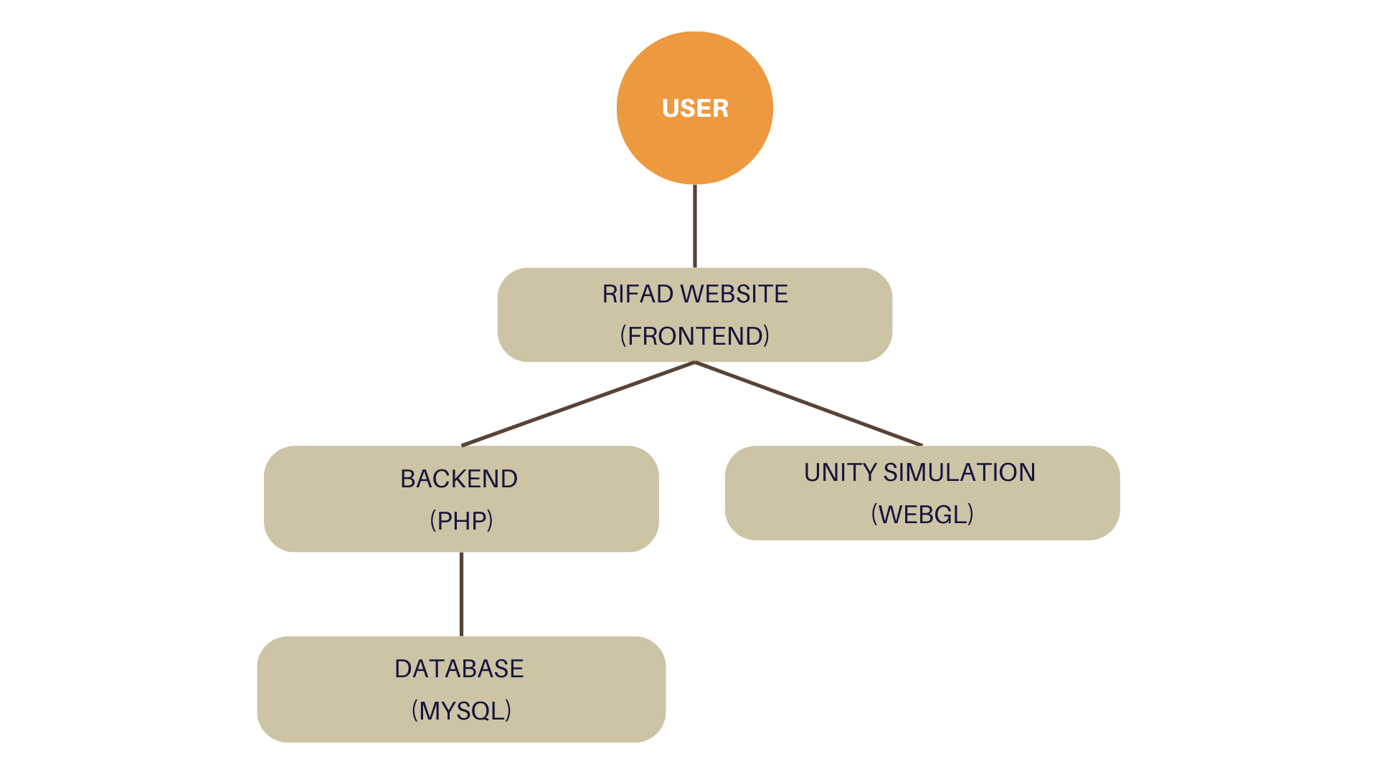

.

## 3.4 Structural model

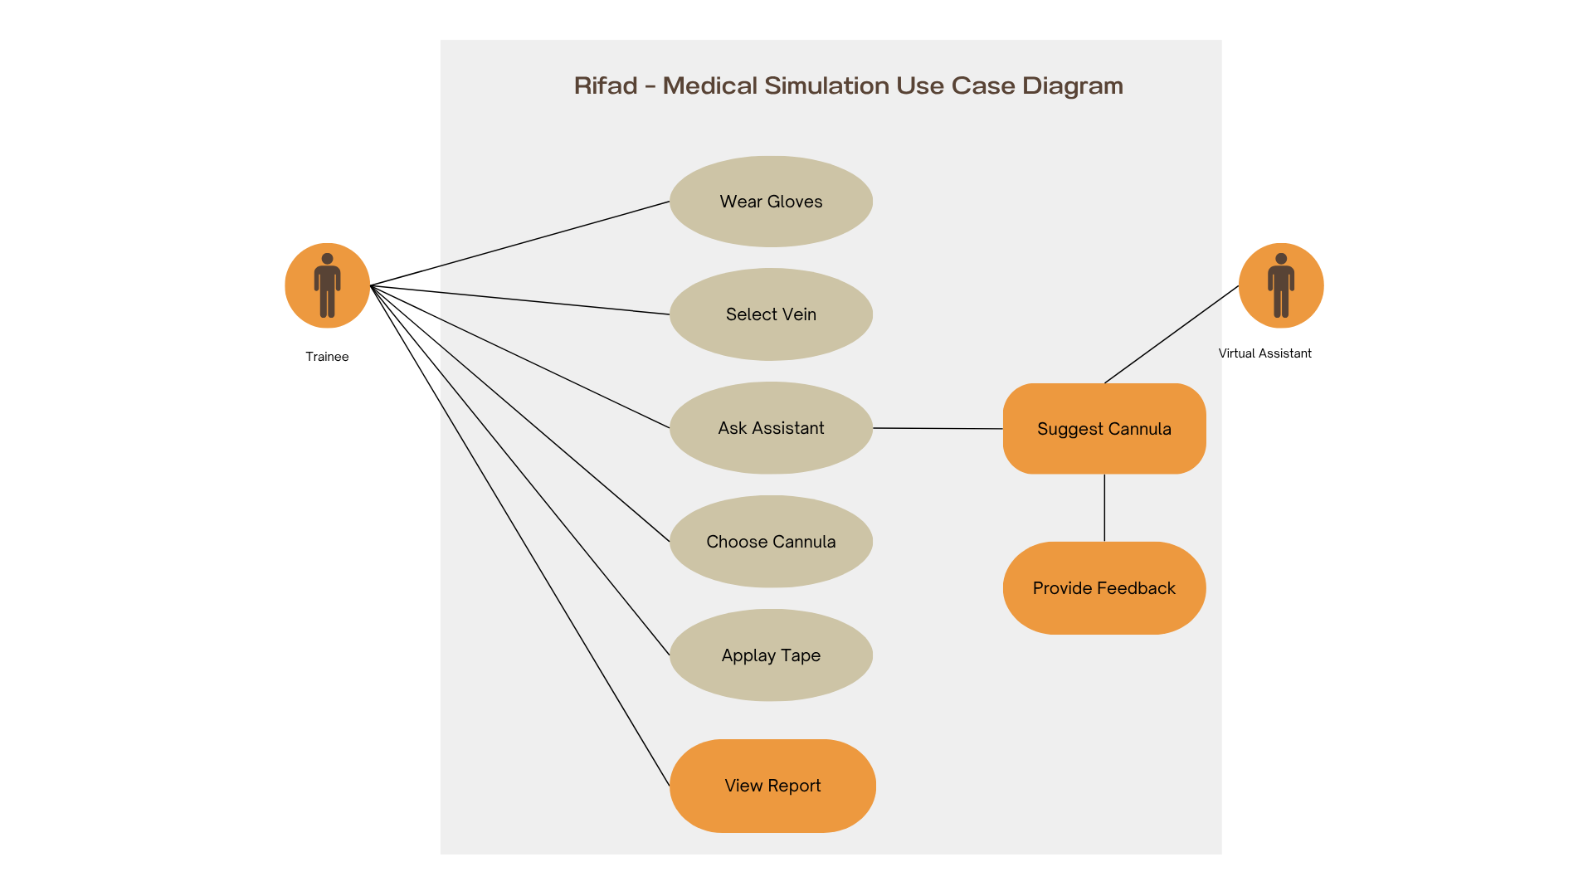

## 3.5 Detailed System Architecture:

## **1. User Interface Module**

## **Provides the front-end for the user to interact with the VR environment.**

## **Supports both VR hand controllers and desktop input (mouse/keyboard).**

## **Displays step-by-step instructions, feedback, and performance reports.**

**2. VR Simulation Engine**

* **Built using Unity 3D, this engine handles rendering the 3D clinical environment.**
* **Simulates interactions with virtual objects such as gloves, syringes, cotton pads, and tourniquets.**
* **Captures user actions (e.g., grabbing tools, injecting, discarding items).**

**3. Training Logic Module**

* **Contains procedural logic for validating correct order of actions.**
* **Detects missed or incorrect steps.**
* **Triggers real-time alerts or success messages based on user behavior.**

**4. Feedback and Assessment Engine**

* **Evaluates user performance based on accuracy, sequence, and efficiency.**
* **Generates a score and summary report at the end of each session.**
* **Logs user performance for future review or export**

**5. AI Assistant Module**

* **Offers pre-programmed responses to user questions (e.g., "What size needle should I use?").**
* **Helps guide users during the procedure by providing static medical knowledge.**

## **6. Data Management Module**

## **Stores user performance data locally (or on a cloud backend in future versions).**

## **Manages session logs and feedback history.**

## 3.6 User Interface :

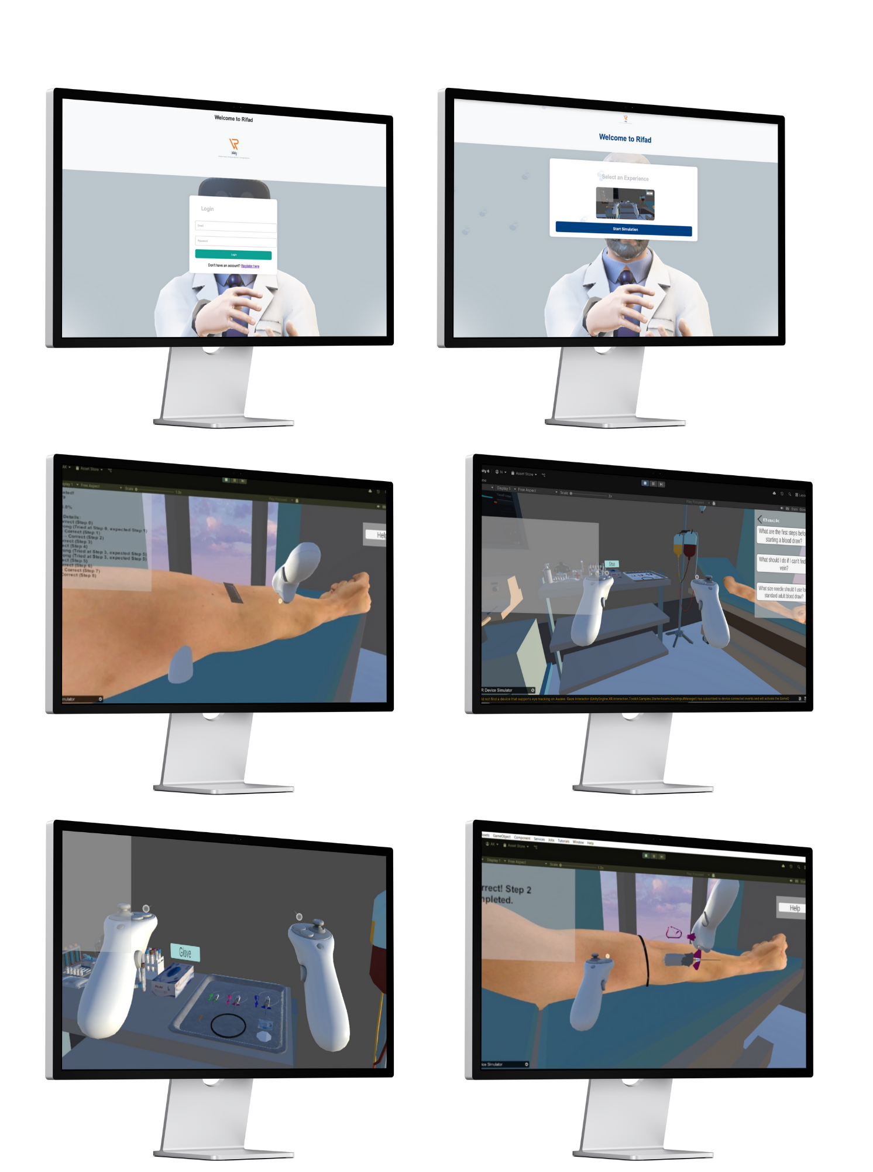

## 3.7 Quality Assurance:

## **To ensure Rifad delivers a high-quality, reliable, and user-friendly training experience, several quality assurance measures were implemented throughout the development process:**

## **1. Functional Testing**

## **Each feature was tested independently to ensure it performs as expected (e.g., tool interaction, step validation, feedback display).**

## **Scenarios with correct and incorrect procedures were simulated to verify logic accuracy.**

## **2. Usability Testing**

## **The interface was reviewed by health sciences students and non-technical users to ensure clarity and ease of use.**

## **Adjustments were made based on feedback to enhance user guidance and visual cues.**

## **3. Performance Testing**

## **The system was tested on multiple devices (desktop and VR headset) to ensure smooth performance and minimal lag during interaction.**

## **Load tests were performed on feedback and scoring modules to verify stability under multiple sessions.**

## **4. Error Handling**

## **Real-time detection of skipped or incorrect steps was implemented with appropriate alerts.**

## **Safety messages and fallback behaviors were built into the simulation flow.**

## **5. Consistency & Accuracy**

## **Medical procedure flow (e.g., blood draw) was reviewed against standard healthcare protocols.**

## **All feedback messages and assistant responses were verified by consulting medical training materials.**

## **These QA efforts aim to ensure that users not only experience a realistic simulation, but also receive accurate training aligned with healthcare education standards.**

## 3.8 Acceptance Criteria:

**Acceptance Testing Steps:**

* **Unit Testing: Test each component to ensure it functions as expected.**
* **Integration Testing: Verify that components work together seamlessly.**
* **System Testing: Ensure that the complete system performs correctly under various conditions.**
* **User Acceptance Testing (UAT): Involve end-users (healthcare providers) to validate that the system meets their needs and expectations.**
* **Compliance and Security Testing: Ensure the system adheres to healthcare regulations (e.g., HIPAA) and is secure.**
* **Performance Testing: Verify that the system can handle large amounts of data and multiple users without compromising performance.**

## 

## 3.9 Future Consideration:

**Rifad is designed to be scalable and extensible. Future development plans include:**

**1. Additional Medical Scenarios**

* **Expanding the platform to support other procedures such as:**
* **Cardiopulmonary resuscitation (CPR)**
* **Wound cleaning and dressing**
* **Managing asthma or diabetic emergencies**
* **Vital signs monitoring**

**2. Dynamic Virtual Assistant**

* **Enhancing the AI assistant to support voice-based interaction.**
* **Integrating NLP (Natural Language Processing) to understand open-ended questions.**

**3. Cloud-Based Progress Tracking**

* **Allowing users to save their performance history across devices.**
* **Supporting instructor dashboards to monitor student progress.**

**4. Certification Integration**

* **Generating completion certificates for users who pass training modules.**
* **Making the platform useful for both personal learning and formal institutional training.**

# Chapter Four: Experimental Setup and Configuration

**4.1 Hardware and Software Setup:**

**To develop and test the Rifad VR training platform, the following hardware and software environments were utilized:**

**Hardware Requirements:**

* **Development PC with:**
* **Intel Core i7 Processor or higher**
* **16GB RAM minimum**
* **NVIDIA GTX 1660 or equivalent GPU**
* **Oculus Quest 2 headset with hand controllers (optional for full VR experience)**
* **Standard mouse and keyboard for desktop simulation**

**Software Requirements:**

* **Windows 10/11 Operating System**
* **Unity Game Engine (Version 2021.3 LTS)**
* **Visual Studio (for C# scripting)**
* **Oculus Integration SDK for Unity**
* **SQLite or JSON for lightweight local data storage Version control: Github**

**4.2 Installation and Configuration:**

**Unity (version 6000.0.25) was installed as the main development engine. A new 3D project was created with XR plug-in settings enabled to support VR interaction. Medical 3D models such as syringes, gloves, and patient arms were downloaded from Sketchfab and imported into the Unity scene. C# scripts were added to control interaction and step validation. The simulation was tested using Unity’s Play Mode on desktop.**

**4.3 Tools and Technologies Used**

* **Unity 2022.3 LTS**
* **C# for scripting simulation**
* **HTML, CSS, JavaScript for frontend**
* **PHP for backend logic**
* **MySQL for storing user data**
* **XAMPP for local hosting**
* **WebGL for simulation deployment online**

**4.4 System Training (for AI systems)**

**Rifad includes a simple AI assistant that provides pre-programmed responses to user questions during the simulation.**

**AI Training Process:**

* **A list of common procedural questions was compiled (e.g., "What size needle should I use?")**
* **Accurate, simple answers were drafted based on healthcare training standards.**
* **Each question-answer pair was hardcoded into the system as a static decision tree.**
* **Future versions may include dynamic AI using NLP and machine learning.**

**Note: No machine learning model was trained in this version; the AI assistant is rule-based only.**

**4.5 Testing and Validation:**

**The system was tested across different environments and by various user types to ensure performance, reliability, and educational effectiveness.**

**Testing Methods:**

* **Unit testing of all functional scripts and logic components.**
* **Usability testing by health science students to evaluate clarity and navigation.**
* **Cross-device testing (desktop and VR) to validate consistent experience.**

**Validation Criteria:**

* **Accurate detection of procedural steps and errors**
* **Smooth transitions and interactions**
* **Real-time feedback and scoring accuracy**
* **User engagement and successful task completion**

**4.6 Risk Analysis and Mitigation:**

**Several risks were identified during the development of the system, including:**

* **There is a risk that users may experience hardware limitations, especially on lower-end devices. To mitigate this, a desktop-compatible version was developed alongside the VR experience.**
* **Some users may feel disoriented or experience motion sickness during VR usage. The system was designed with minimal motion and smooth camera transitions to reduce this effect.**
* **Inaccurate or confusing user interfaces could affect learning outcomes. To address this, the interface underwent usability testing with both health students and non-technical users.**
* **The absence of tactile feedback may reduce the realism of the simulation. Visual cues, sound effects, and interactive feedback were implemented to simulate responses and enhance realism.**
* **Errors in the medical procedure logic could lead to misinformation. All procedural steps were verified against licensed medical sources and reviewed for accuracy.**

# Chapter Five: Results and Discussion

**5.1 Results:**

**Upon completing the development of Rifad’s initial simulation module (blood draw procedure), the system was tested across different environments and with various user profiles. The following results were observed:**

* **The system successfully guided users through the correct steps of the procedure, including hand hygiene, glove application, tourniquet placement, and proper needle usage.**
* **Real-time feedback alerts were triggered accurately when users skipped or incorrectly performed a step.**
* **The scoring and performance summary were generated correctly after each session.**
* **The AI assistant responded reliably to pre-defined user questions, enhancing the guidance experience.**
* **Desktop and VR testing showed that the simulation was responsive, with minimal technical issues and good frame rates on compatible hardware.**
* **User testing was conducted both through direct VR headset usage and via the embedded WebGL version, confirming that the simulation is functional, responsive, and provides accurate feedback across both platforms.**

**5.2 Discussion:**

**The development and evaluation of Rifad highlight the potential of VR-based platforms in improving procedural training in healthcare. Compared to traditional methods such as classroom lectures or manikin-based simulations, Rifad provides several advantages:**

* **Users can repeat the procedure as many times as needed, reducing performance anxiety and improving retention.**
* **Real-time feedback allows learners to recognize and correct mistakes during the simulation.**
* **The system promotes independent learning, which is especially valuable in situations where access to instructors or training labs is limited.**
* **The AI assistant provides contextual support and mimics the presence of an educator, making the simulation more informative.**

**Importantly, Rifad was designed not only for students but also with non-specialist caregivers in mind. This inclusivity opens the door for empowering families caring for chronically ill individuals to learn medical basics safely and confidently.**

**The positive outcomes from the initial testing phase support the idea that VR can bridge gaps in both formal and informal health education.**

**5.3 Limitations:**

**Despite its promising performance, Rifad has a few limitations that should be acknowledged:**

* **The current version supports only one medical scenario (blood draw), which limits the system's coverage of other critical procedures.**
* **The virtual assistant is based on a static, rule-based system and cannot interpret open-ended or voice-based queries.**
* **While the simulation offers visual and auditory feedback, it lacks physical (tactile) feedback, which may reduce realism in tasks that depend on touch.**
* **The simulation requires moderate to high-performance hardware for optimal VR use, which may limit accessibility for some users**

**These limitations present opportunities for further enhancement and expansion in future versions of Rifad.**

# Chapter Six:Conclusion

**6.1 Summary of Work:**

**This project introduced Rifad, a smart virtual reality–based training platform designed to teach clinical procedures in a simulated, safe, and interactive environment. The first version of the system focused on the blood draw procedure and included key components such as:**

* **A VR environment built using Unity**
* **Step-by-step interaction logic and real-time feedback**
* **An AI-based virtual assistant for basic guidance**
* **Performance scoring and reporting tools**

**In addition to the VR simulation, the project also introduced a supporting website that allows users to register, log in, and access the simulation online. By combining immersive VR with an accessible web platform, Rifad bridges the gap between advanced medical training and user-friendly access. This dual approach ensures that learners can benefit from both realistic interaction and easy access via browsers.**

**6.2 Lessons Learned:**

**Throughout the project, several technical and practical insights were gained:**

* **Developing interactive VR environments requires careful planning of user flow and experience to ensure clarity and engagement.**
* **Error-handling and feedback systems play a crucial role in learning-focused simulations.**
* **Static AI systems can provide valuable assistance even without advanced natural language understanding, as long as questions and responses are well-designed.**
* **Usability testing is essential, especially for educational tools aimed at non-technical users.**
* **Flexibility and scalability in the system architecture are critical to enable future updates and new scenarios.**

**6.3 Future Work:**

**Based on the results and limitations of the current version, future development of Rifad will focus on the following:**

* **Adding more first aid and clinical procedures such as CPR, wound dressing, and emergency care.**
* **Enhancing the AI assistant with dynamic, voice-based support using NLP technologies.**
* **Developing a cloud-based performance dashboard for institutions to track students' progress.**
* **Creating personalized training paths based on user performance data.**
* **Exploring multi-language support to expand accessibility to non-English-speaking users.**
* **Conducting large-scale testing in academic and community settings for broader evaluation.**

**These enhancements will help transform Rifad into a comprehensive, inclusive, and adaptive platform for health education and community empowerment.**

# References

Freina, L., & Ott, M. (2015). A literature review on immersive virtual reality in education: State of the art and perspectives. The International Scientific Conference eLearning and Software for Education, 1, 133–141. https://doi.org/10.12753/2066-026X-15-020

Foronda, C. L., Fernandez-Burgos, M., Nadeau, C., Kelley, C. N., & Henry, M. N. (2020). Virtual simulation in nursing education: A systematic review spanning 1996 to 2018. Simulation in Healthcare, 15(1), 46–54. https://doi.org/10.1097/SIH.0000000000000411

Kyaw, B. M., Saxena, N., Posadzki, P., Vseteckova, J., Nikolaou, C. K., George, P. P., ... & Car, J. (2019). Virtual Reality for health professions education: Systematic review and meta-analysis by the Digital Health Education Collaboration. Journal of Medical Internet Research, 21(1), e12959. https://doi.org/10.2196/12959

Levine, C., Halper, D., Peist, A., & Gould, D. A. (2018). Bridging troubled waters: Family caregivers, transitions, and long-term care. Health Affairs, 29(1), 116–124. https://doi.org/10.1377/hlthaff.2009.0520

# Appendices

**A1. Project Timeline**

|  |  |  |
| --- | --- | --- |
| **Phase** | **Phase** | **Phase** |
| **Phase 1 – Planning** | **Defined project idea, goals, and scope** | **Week 1–2** |
| **Phase 2 – Design & Prototyping** | **Designed system architecture and 3D interaction** | **Week 3–4** |
| **Phase 3 – Development** | **Built VR environment, interaction logic, and UI** | **Week 5–6** |
| **Phase 4 – Testing & Quality Check** | **Tested features and improved user experience** | **Week 7–9** |
| **Phase 5 – Documentation & Report** | **Completed final report, user guide, and diagrams** | **Week 10–11** |
| **Phase 6 – Presentation Preparation** | **Created slides and demo for final presentation** | **Week 12–13** |

**A2. Source Code Documentation**

**The complete source code and related documentation are available on GitHub:**

**GitHub Repository:  
🔗** [**https://github.com/Noor7abouissa/Rifad**](https://github.com/Noor7abouissa/Rifad)

**A3. User Manuals:**

**uploaded on GitHub**

**A4. Additional Diagrams**

**There are currently no additional diagrams included in this report**